12 Days of Evolutionary Deception
by Dr. Elizabeth Mitchell on January 14, 2016

“The 12 Days of Evolution”—a PBS-sponsored video series—deceptively makes Darwinian evolution appear obvious and undeniable.

News Source
- PBS: “The 12 Days of Evolution - Complete Series”
Closing out the holiday season in an ironically traditional style, the PBS-sponsored website It’s Okay To Be Smart posted a dozen short videos called “The 12 Days of Evolution” on YouTube, completing the set just in time for post-Christmas viewing. The “12 Days of Christmas” is an 18th century folk song celebrating the days between Christmas and the Feast of the Epiphany. That day commemorates the successful quest of the Magi (Mt 2:1-12) to find and worship the infant Jesus Christ, the incarnate Son of God.
These 12 video gifts—conveniently embedded (as shown in this screen shot) as clickable finches in Darwin’s beard—encourage viewers to reject God’s Word from its beginning. Substituting fallible man’s evolutionary explanation of origins for God’s account undermines the foundation for faith in Jesus Christ—our Creator (Col 1:16,17) who came to live among man and to die, purchasing our salvation (1Pe 1:18; Heb 2:9).
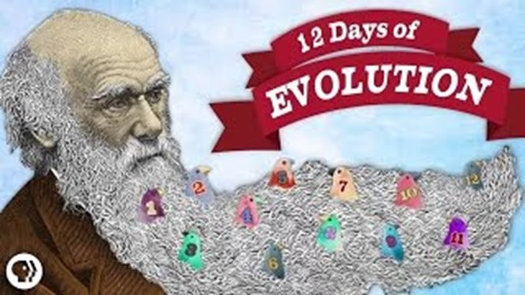
Perhaps you rang in the new year with the “12 Days of Evolution.” Perhaps it has raised some concerns among your friends and family. In this article we’ll briefly examine the deadly dozen and even some truths within them. And we’ll provide quick links to many articles and videos addressing their evolutionary claims. This handy reference guide will equip you to pass on this gift of truth: We don’t have to check our brains at the door to trust God’s Word from the very first verse and to put our faith and eternal hope in God’s Son Jesus Christ, our Creator and Savior.
The 12 Days of Evolution
- What Is Evolution, Anyway?
- Is Evolution Random?
- Have We Ever Seen Evolution Happen?
- Can Evolution Make an Eye?
- Have We Ever Seen a New Species Arise?
- Evolution Is Dumb
- Why Do Men Have Nipples?
- Does Evolution Violate the 2nd Law of Thermodynamics?
- Can Evolution Create Information?
- Why Are There Still Monkeys?
- Are Humans Still Evolving?
- Does Evolution Have a Point?

The Deadly Dozen
“The 12 Days of Evolution” deceptively uses observable facts to support unverifiable evolutionary claims. Thus biologist Dr. Joe Hanson, the narrator, makes evolutionary assertions appear undeniable. On his website’s many other videos he presents a variety of scientific topics. Some cover observational science—things that scientists can repeatedly observe and test using the scientific method. Others present unverifiable evolutionary ideas as if they were truly testable and verifiable rather than just the worldview-based conclusions of historical science, a historical science that rejects God’s eyewitness account of the unobservable past.
Evolution’s biggest whopper is the claim that all life evolved from a common ancestor. In the opening video, “What is Evolution, Anyway?,” Dr. Hanson uses the observable process of natural selection as his evidence in support of this unverifiable and insupportable claim. He first correctly illustrates the process of natural selection when a grey rabbit on snow becomes prey while a white bunny survives to produce a white population. Then, having said that the same biological rules apply to all creatures, he smoothly segues into a definition of natural selection that includes the idea that “all life is descended from a common ancestor.” But of course his illustration only dealt with variation within a created kind of animal, not with the evolution of new and different kinds of animals.
We as Bible-believing creation scientists often point out that random natural processes cannot create the genetic blueprints to build new and more complex organisms. Taking a stab at this, in the second video, “Is Evolution Random?,” Dr. Hanson says that no, it isn’t. He explains that the tiny DNA changes from which natural selection selects are randomly generated mutations but that natural selection is not. He offers the metaphor of a house as a kind of organism and explains that the randomly generated blueprints for “houses” produce billions that fail to be selected and fall down but many that do stand the test of trials and time. Summing it up, he says, “Life isn’t just chance; it’s the nonrandom selection of random variation, and it built this beautiful city called Life.” Yet nothing in observational science has shown that selection from random genetic variations can produce new kinds of organisms. Nevertheless, though admitting that natural selection “might not tell us how life began,” Dr. Hanson maintains that “it tells us how all living things came to be the way they are—bacteria, bugs, or beagles” beginning from a common ancestor.
Despite Dr. Hanson’s Darwinian claims and glowing metaphors, natural selection cannot provide a way for one kind of animal to evolve into a completely new and different kind of animal, no matter how many small changes are spread over how many generations. Organisms reproduce and vary only within their created kinds, and extrapolating this sort of variation to support Darwinian evolution is, at best, wishful thinking. Natural selection is not the same thing as molecules-to-man evolution. And mutations, random or otherwise, do not provide the raw material for it. Neither supplies the mechanism for upward evolution nor fuels the engine that supposedly drives it.
Natural selection is an observable, God-ordained process that preferentially allows some varieties of organisms to survive and reproduce, producing populations of those best able to face the challenges in this this sin-cursed world. It takes advantage of the variations within each created kind of organism but does not generate brand new genetic information of the kind needed for molecules-to-man evolution.
After opening the video series with the famous—and false—claim that “Nothing in biology makes sense except in the light of evolution,” Dr. Hanson claims that “centuries of observing nature has shown us that all life is related.” This is untrue. Centuries of observing nature has shown us that all living things have a lot in common. But similarities and common designs do not prove the common ancestry of all living things in the unobservable, untestable past. In fact, since biological observations affirm the biblical truth that living things only reproduce and vary within their created kinds, this leap is not only illogical but also imaginative and false.
Other videos in the series continue the pattern of promoting observable variation within a created kind as support for the insupportable Darwinian evolution of complexity. For instance, episode 3, “Have We Ever Seen Evolution Happen?,” cites as an example the emergence of cricket populations unable to chirp. Survival being affected by natural selection, some of the information is lost and the characteristics of the animals are altered, but no new information is created by this process. (Learn more in “Silence of the Crickets Speaks Volumes About Variation and Selection.”) Episode 5, “Have We Ever Seen a New Species Arise?,” recounts the history of London’s subway mosquitos. In this example the genetic material being passed between members of reproductively isolated groups is limited, and through ordinary genetic processes speciation occurs. Yet in these examples mosquitos remain mosquitos and crickets remain crickets. Information may be lost through mutation, and genetic diversity may be lost in isolated groups, but evolutionary scientists have demonstrated no mechanisms by which information can be gained to produce different, more complex animals of another kind.

Evolution: Do the Eyes Have It?
Evolutionists are fond of pointing to the eye as an example of evolution’s power. Just as physicist Neil de Grasse Tyson made much of it in the second episode of his Cosmos series, so biologist Joe Hanson does here in episode 4, “Can Evolution Make An Eye?” Evolutionists assert that it is so easy to evolve an eye that convergent evolution has done it many times in diverse, essentially unrelated branches of the tree of life. Even one kind of lowly, brainless protozoan has an eye-like ocelloid. Want to know the truth about these claims? Watch Dr. Tommy Mitchell’s video presentation Evolution: The Eyes Don’t Have It here and you’ll not only find out how absurd it is to think that natural evolutionary processes could generate eyes but also how perfectly our master Designer, God, has specially engineered the human eye.
https://www.youtube.com/watch?v=GTUTUkYMTus
Dr. Tommy Mitchell, a physician and Answers in Genesis speaker, elaborates on many problems with claims that vision evolved and shows how perfectly the human eye is designed in this online video Evolution: The Eyes Don’t Have It.

Evolution’s Design Flaws?
Some claim that the human eye’s design is flawed, an “obvious” result of evolution’s blindness, its inability to plan ahead, the limitations of working with previously evolved raw material. (We discussed this in our book review of Bill Nye’s Undeniable.) If you’ve watched Evolution: The Eyes Don’t Have It you already realize that the human eye is a marvel of engineering that solves several potential problems elegantly and efficiently.
Dr. Hanson offers another popular example of the supposedly inferior products of evolution—the left recurrent laryngeal nerve—in episode 6, “Evolution Is Dumb.” This nerve, he says, travels from the mammalian brain down the neck, into the chest, and then after wrapping around the large artery (aorta) exiting the heart returns to the neck to innervate the voice box. In the giraffe, Dr. Hanson says, this nerve’s detour is 15 feet. He would have us believe this circuitous path is evidence of how evolution works, given that it cannot plan ahead and must work with previously evolved material.
But the trip that embryological development mandates for this nerve is not a design flaw, and it is not purposeless. The recurrent laryngeal nerves branch from the vagus nerve, not the brain. This vagus nerve emerges from the brain and travels down the neck to the chest where it helps control the heart. Near the heart, just below the aorta, the left recurrent laryngeal nerve originates from the vagus nerve, loops beneath the aortic arch and then sends additional branches to several important structures in the chest and neck as it ascends to innervate the voice box.
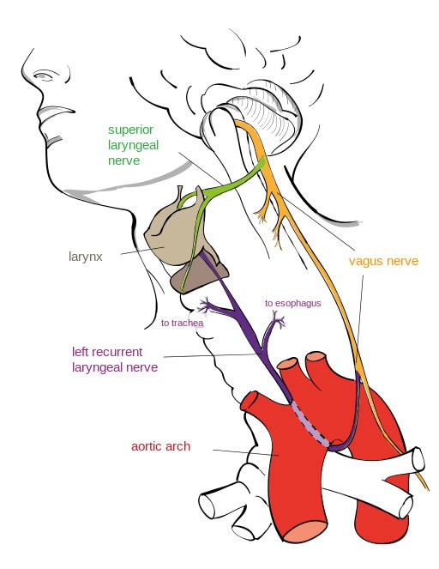
As indicated in this illustration, the left recurrent laryngeal nerve, the nerve supply to the left side of your voice box, branches off of the vagus nerve near the heart. It loops under the aortic arch—the enormous blood vessel through which oxygenated blood exits the heart—and gives off several branches to other structures as it ascends through the chest and neck to reach the voice box. The nerve is drawn into this same pattern as the embryo grows in all vertebrates, even long-necked giraffes. Illustration by Jkwchui (Based on drawing by Truth-seeker2004), via Wikimedia Commons.
At Answers in Genesis we maintain a list of “Arguments Creationists Should Not Use.” If evolutionists had a similar list, they ought to include on it examples like these—using speciation to support upward evolution and claiming that certain excellent designs illustrate evolution’s powerful effects and poor engineering.

Trivial Pursuits
The next episode, “Why Do Men Have Nipples?,” points out that it costs evolution less to keep nipples on males than to draft a whole new design. Here Dr. Hanson only explains that not every trait has to have an active function so long as it doesn’t hurt survival. Yet while male nipples “cost nothing” to keep, his assumption that evolution created those nipples and all the rest of our anatomy is flawed and unsupported. (Read “Why Do Men Have Nipples?” if you want to know the real answer.)
In the episode “Does Evolution Violate the 2nd Law of Thermodynamics?,” Dr. Hanson asserts that it does not because the sun’s energy has powered biological evolution. The sun’s energy has been powering a lot of things in our world for about 6,000 years, but since Darwinian evolution is not a historical reality, Dr. Hanson is incorrect in claiming that the sun has been evolution’s energy source. Read more about this in Dr. Danny Faulkner’s article “Does the Second Law of Thermodynamics Favor Evolution?”
“Why Are There Still Monkeys?” explains that evolutionists do not claim that humans evolved from monkeys or apes, but only from an ape-like ancestor. However, knowledgeable Bible believers do not use the existence of chimps as evidence against evolution. Check out Dr. Tommy Mitchell’s article “If Humans Evolved from Apes, Why Do Apes Exist Today?” in our Arguments to Avoid.
“Are Humans Still Evolving?” offers examples showing how humans have varied and how mutations have sometimes offered selective advantages to groups of people. We have on our website articles discussing these: “Dairy Products Among Early Saharan Inhabitants” explains how natural selection can promote persistence of the already existingability to digest milk into adulthood. No new information is created and no evolution occurs. Similarly, sickle cell trait in Saharan inhabitants can improve the chances of surviving malaria, yet the people with this mutation are not examples of upward evolution and have not evolved new information. It is the loss of information in fact that makes their red blood cells inhospitable to malaria-causing organisms. (See “Link Between Sickle-Cell and Malaria Resolved.”) Furthermore the high-altitude tolerance found in Tibetan natives, mentioned in the video as an example of ongoing human evolution, does not indicate they have evolved some new genetic information. Instead, a variation in one regulatory gene keeps them from developing excessively thick blood in response to their thin air. Read about this height of variation in “Denisovan Gene Gave Tibetans Their High-Altitude Tolerance.” These examples only demonstrate variation among humans.

It’s All About Information
“Can Evolution Create Information?” We often point out that experimental biology has never shown a way that the information necessary for molecules-to-man evolution can be created. Yet in episode 9, Dr. Hanson asserts that natural evolutionary processes do create new information when genes randomly duplicate and leave the unconstrained extra copies to take on new functions. Gene duplications are a kind of mutation, sometimes leading to amplification of an existing genetic function or application of the gene’s existing information in a different anatomical context—a possible mechanism by which snakes become venomous. Yet a million copies of an informative book do not contain a million-times more information, just more copies of the same information. So gene duplications do not provide the raw material for upward evolution.
Furthermore, not all that is labeled genetic duplication is really a result of duplication at all. As we pointed out when evaluating claims that 70% of the human genome could be traced back to an ancestral acorn worm-like creature, many of our genes structurally resemble genes elsewhere within our genome. These DNA sequences may vary as much as about 10% and have their own functions, and evolutionists view them as mere “copies” and assume they are evidence that gene duplication provided the raw material through which novel evolutionary functions evolved. They do not acknowledge that structurally similar or even identical DNA sequences, including those that serve diverse functions within the genome, are a legitimate feature of God’s good design.
Life does require a source of information, and molecules-to-man evolution cannot supply it. Learn more about the true source of genetic information in numerous articles and videos on the Genetics and Information Theory topic pages.

What Is Man?
“The 12 Days of Evolution” series concludes with an “inspirational” message reminiscent of Neil de Grasse Tyson’s assertion in Cosmos: A SpaceTime Odyssey that understanding his place in the evolutionary order—his “kinship with all life on earth”—was a “soaring spiritual experience.” In “Does Evolution Have a Point?” the evolutionary view is that we are merely one species that happened to survive. We humans should refrain from thinking of ourselves as somehow special or as “the pinnacle of evolution,” Hanson chides us, because evolution has no purpose. Instead, again echoing the “you are stardust” mantra sung by Tyson and outspoken atheist Lawrence Krauss, he says that knowing “we are just one small part of something bigger, that we’re made of the same stuff as what’s up there” in the night sky is “a profoundly humbling experience.”
Evolutionists like Tyson and Hanson revel in their own insignificance and pat themselves on the back for being intelligent enough to deny they were intelligently designed. But this is a false humility. In reality they are exalting their own fallible ideas above the Word of God their Creator. True knowledge of our place in the universe is genuinely humbling. God has created our marvelously designed bodies and amazing minds, and He made us in His own image. Yet how small we are in comparison to the greatness of the Creator God of the universe! Moreover, how wonderful and how humbling it is when we realize that God loves each one of us despite our sinful nature and rebellious behavior.
When we acknowledge our own sinfulness in comparison to His holiness and realize that we cannot save ourselves but are wholly dependent on the grace God offers through the cross of His Son Jesus Christ, then we can, like the psalmist (Ps 8:4–5), exclaim in amazement, “What is man, that God is mindful of him!”

Further Reading
- 12 Arguments Evolutionists Should Avoid
- Silence of the Crickets Speaks Volumes About Variation and Selection
- Can Neanderthal Noses Sniff Out the Secret Paths of Human Evolution?
- New Function through Gene Duplication
- Attempts to Trace Life Back to Chemical Origins Still Maps the Willful Ignorance of the Hunters
- Vestigial hiccups, folding fish-eyes, and other fables: Our fishy forebears . . . again!
- Caffeine: Convergently Evolved or Creatively Provided

https://answersingenesis.org/reviews/tv/12-days-of-evolutionary-deception/

These were posted daily from 12/14–12/25, then posted together on 12/25/2015.
Convergence is the evolutionary explanation invoked to explain obvious phenotypic similarities in animals of different lineages. Convergent evolution is the notion that when organisms whose ancestral paths have not recently crossed possess a similar feature (phenotype), they evolved that feature independently to cope with similar challenges.
From Cosmos: A SpaceTime Odyssey episode 2, “Some of the Things Molecules Do.” See our review to learn more.

